**D.K.T.E. Society’s Textile and Engineering Institute, Ichalkaranji.**

Department of Information Technology

2019-2020



Mega-Project Name: Smart Security System using IOT and AI.

**Under The Guidance of**

**Mr. A.S.Shelar (sir)**

**DECLARATION**

We the undersigned students of B.Tech I.T. declare that the fieldwork report entitled ***Smart Security System*** written and submitted under the guidance of ***Prof.A.S.Shelar*** is our original work. The empirical findings in this report are based on the data collected by us. The matter assimilated in this report is not a reproduction from any readymade report.

Date: 05/10 /2019 Place: Ichalkaranji.

**Name Signature**

1. **Shivani Patil**
2. **Rutuja Prabhudeasi**
3. **Vinay Sakhare**
4. **Kanishk Shedsale**

**5. Akshaykumar Patil**

**INDEX**

**CONTENTS PAGE**

1. Abstract 4
2. Problem statement 5
3. Problem description 5
4. Introduction 6
5. Introduction
6. Abbreviation
7. Overview
8. Design Constraints 8
9. Use case diagrams
10. Data flow diagram, data dictionary
11. Limitations 11
12. Literature Survey 12
13. References 13

**ABSTRACT**

This project gives an outline for an automatic system to control and secure specific area, based on digital image processing with the help of Internet of Things and AI. The system consists of a sensor, digital camera, database and the smart phone. Sensors are placed in the specific area which alerts camera to start recording the activity in that area. Then video is than divided into frames. Image analysis is performed to detect and recognize and match the image with the stored dataset of the authenticated people. If the image captured does not match with the dataset then an alert message is send to the owner of that area.

.

**PROBLEM STATEMENT**

To provide smart security system to the specific area using IOT (sensors) and AI (human detection).

**PROBLEM DESCRIPTION**

The sensors will sense the motion in the specified area and activate the cameras. These cameras will record the activity and send it for further image analysis. If the human detected from that image does not match with the authenticated people then it generates an alert message as well as alert alarm.

**INTRODUCTION**

In recent years, the security constitutes the most important section of our lives. Automation of a home is an exciting field for security applications. This area has developed with new technologies like Internet of things (IoT) and Artificial Intelligence. In IoT, each device behaves as a small part of an internet node and each node communicate and interact. Artificial intelligence (AI) is the simulation of human intelligence processes by machines, especially computer systems. These processes include learning (the acquisition of information and rules for using the information), reasoning (using rules to reach approximate or definite conclusions) and self-correction.

Currently, security cameras are used in order to construct safety areas, cities, and homes. The camera records the series of images and, when a motion is detected. An IoT-based system is combined with computer vision in order to detect the people. A Raspberry PI 3 card with the size of a credit card was used for this purpose. A motion is detected by the PIR sensor mounted on the Raspberry PI. PIR sensor helps to monitor and get alerts when movement is detected. A human face and body detector is first proposed, based on a simple probabilistic model, to approximately estimate human face and body regions. Afterward, human is detected in the captured image and compared with the stored dataset whether the target human is authenticated or not. An efficient algorithm for humans’ retrieval from large video databases is presented.

* **Abbreviations :**

|  |  |
| --- | --- |
| **Short form** | **Long form** |
| AI | Artificial Intelligence |
| IoT | Internet Of Things |
| DFD | Data Flow Diagram |
| SRS | Software Requirement Specification |

* **Overview of Document:** 
  + - Document include abstract of the project.
* In this document we give a short introduction about our project.
* This document also includes DFD diagrams and use case diagrams information of our project.

**USE CASE DIAGRAM**

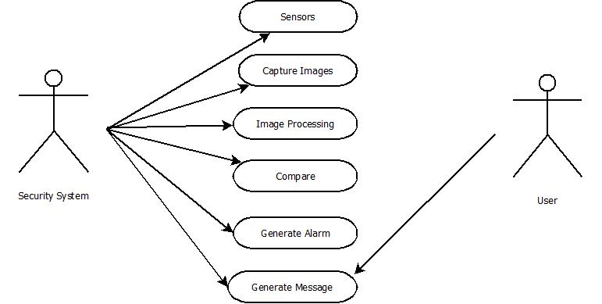

**DATA FLOW DIAGRAM**

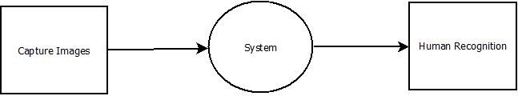

**Level 0**

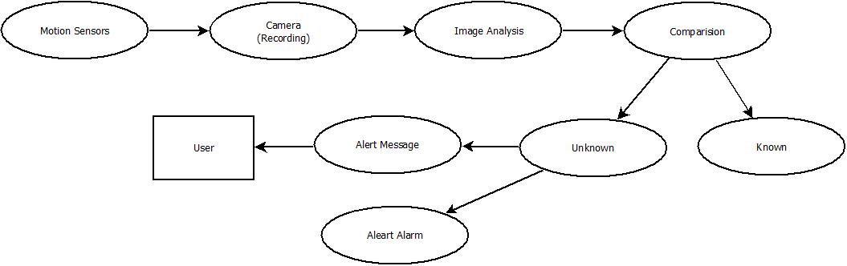

**Level 1**

**LIMITATIONS**

* **IoT based Home Security through Digital Image Processing Algorithms (2017)**

**Authors:-** Beatrice Dorothy, Dr. S. Britto Ramesh Kumar, J. Jerlin Sharmila

This paper was totally based on face recognition for security purpose. It also consists sensors for motion detection which triggers camera to capture an image. This image was then compared with the stored dataset. If the detected person is not authenticated then it would generate the alert alarm as well as alert message to the owner.

Our project concentrates not on the face but the whole human body. Our model also includes sensors which would activate cameras to record the activities. As a result the two drawbacks that are face recognition and image analysis is overcome by including human body detection and video surveillance.

* **Detection of human being and non-human object from image and video sequences(2017)**

**Authors:-** Sudip Kumar Rajak, Sayantan Mondal, Israj Ali.

This paper worked on large video recorded by the cameras. The model just identified objects and human beings from the video. But the authenticated human was not detected.

Our model overcome this drawback by not only identifying human and objects but also recognize authenticated human for security reasons.

**LITERATURE SURVEY**

1. Face Recognition System Using IoT (November 2017)  
   Sandesh Kulkarni, Minakshee Bagul, Akansha Dukare, Prof. Archana Gaikwad
2. IoT based Home Security through Digital Image Processing Algorithms (2017)  
   Beatrice Dorothy, Dr. S. Britto Ramesh Kumar, J. Jerlin Sharmila
3. Deep Neural Network for Human Face Recognition (January 2018)  
    Dr. Priya Guptaa, Nidhi Saxenaa, Meetika Sharmaa, Jagriti Tripathia
4. Face Recognition and IoT Based Smart Lock Access System (2018)  
   Numitha M N1, Taha Noorain1, Amulya S Patil1, Navyashree H V1, Ms. Nagalakshmi T S2.
5. A Smart Security System with Recognition (December 2018)  
   Trung Nguyen, Barth Lakshmanan and Weihua Sheng
6. Smart Home Management System Based on Face Recognition Index in Real-time (2019)

Shakir Fattah Kak , Firas Mahmood Mustafa

**REFERENCES**

* www.geeks4geeks.com
* www.stackoverflow.com
* [www.w3schools.com](http://www.w3schools.com)
* [www.udemy.com](http://www.udemy.com)